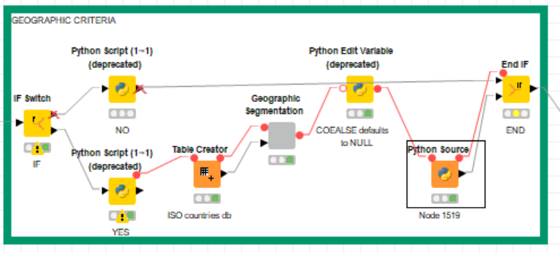

Inside the Geographic segmentation metanode

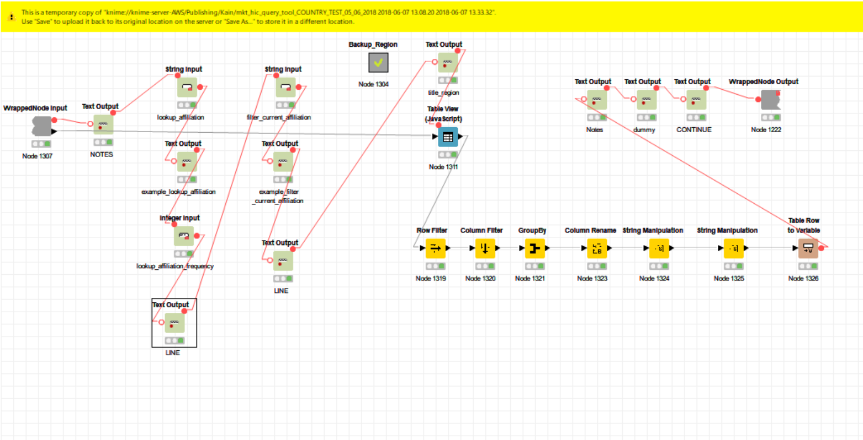

Python Edit Variable node
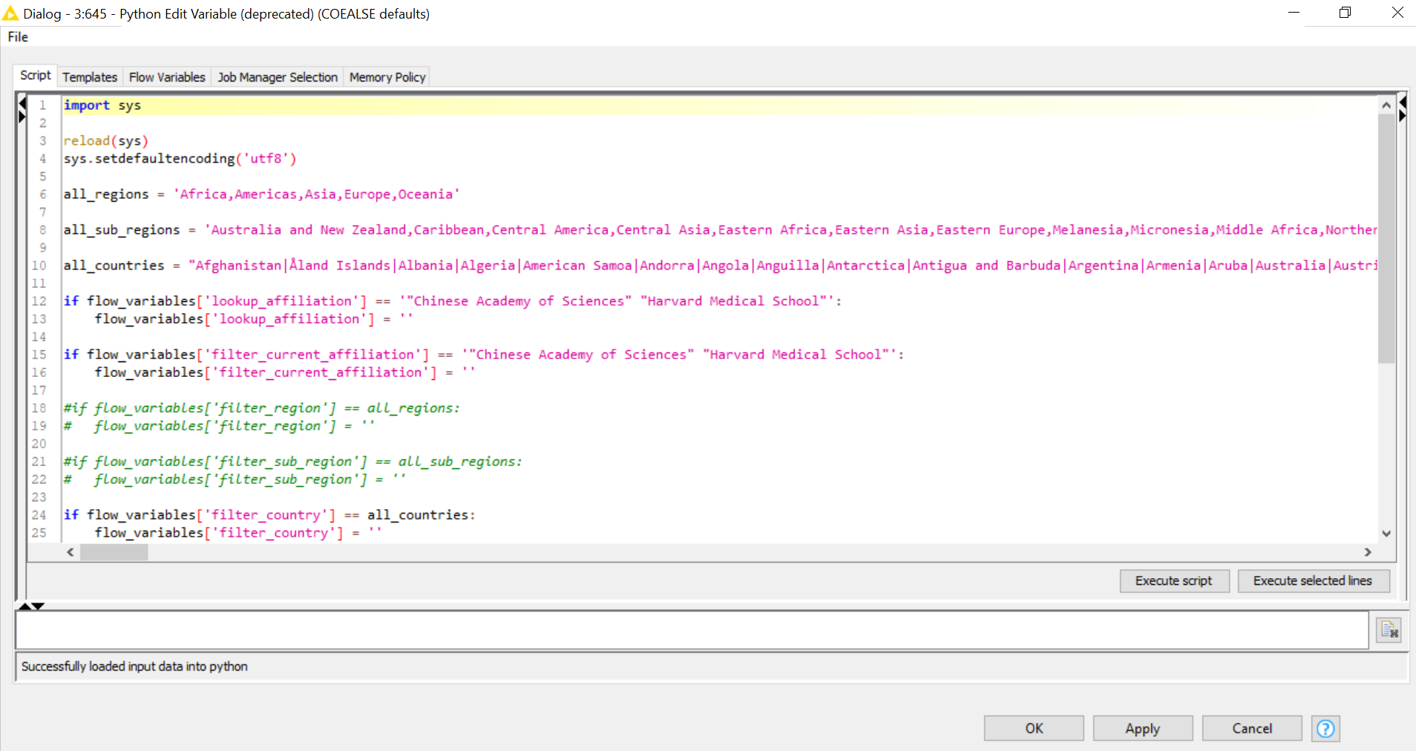

Python Source node
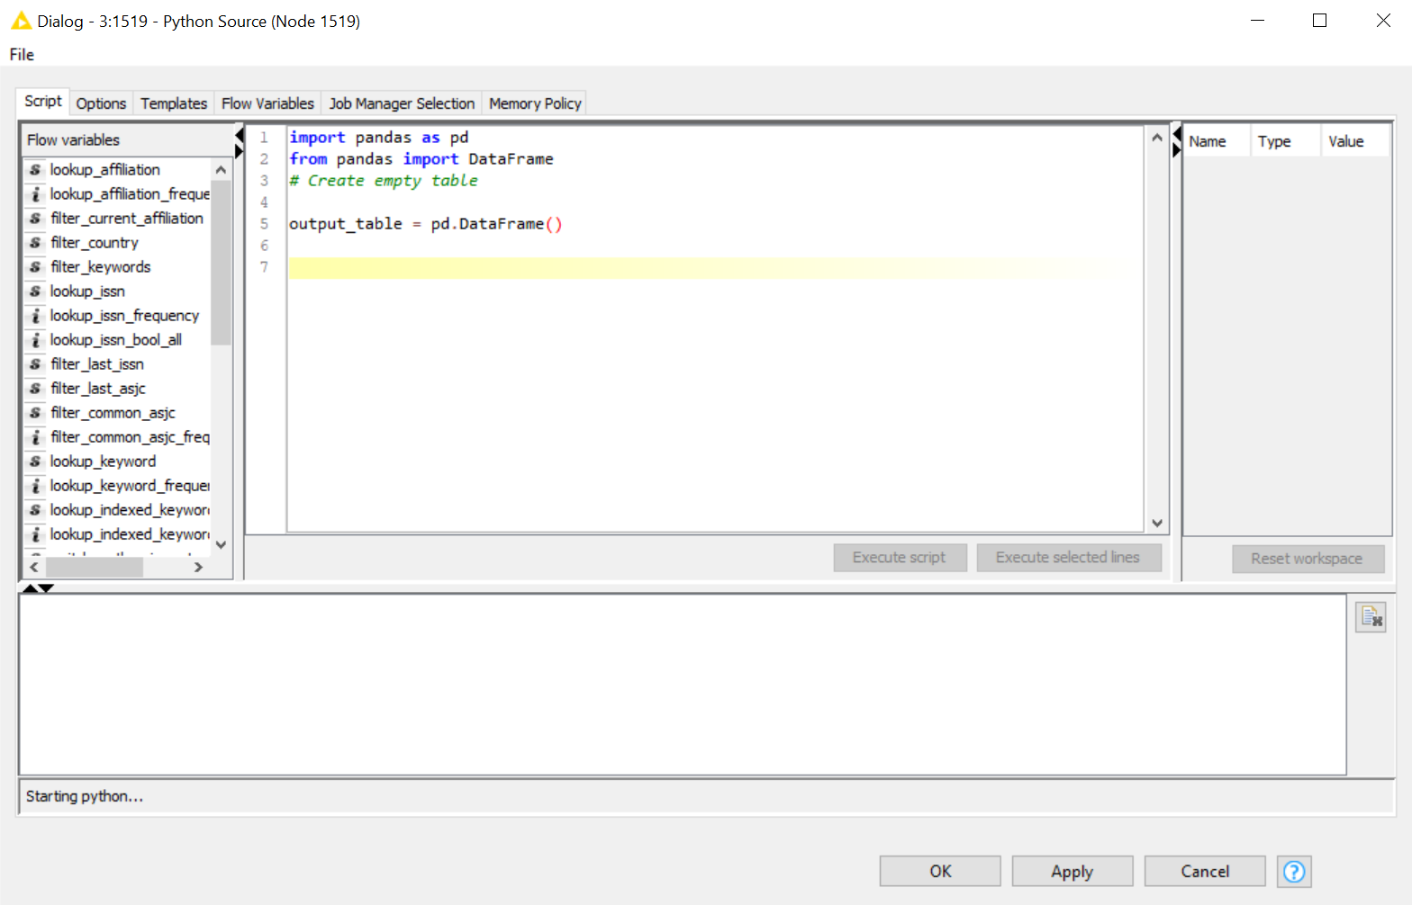

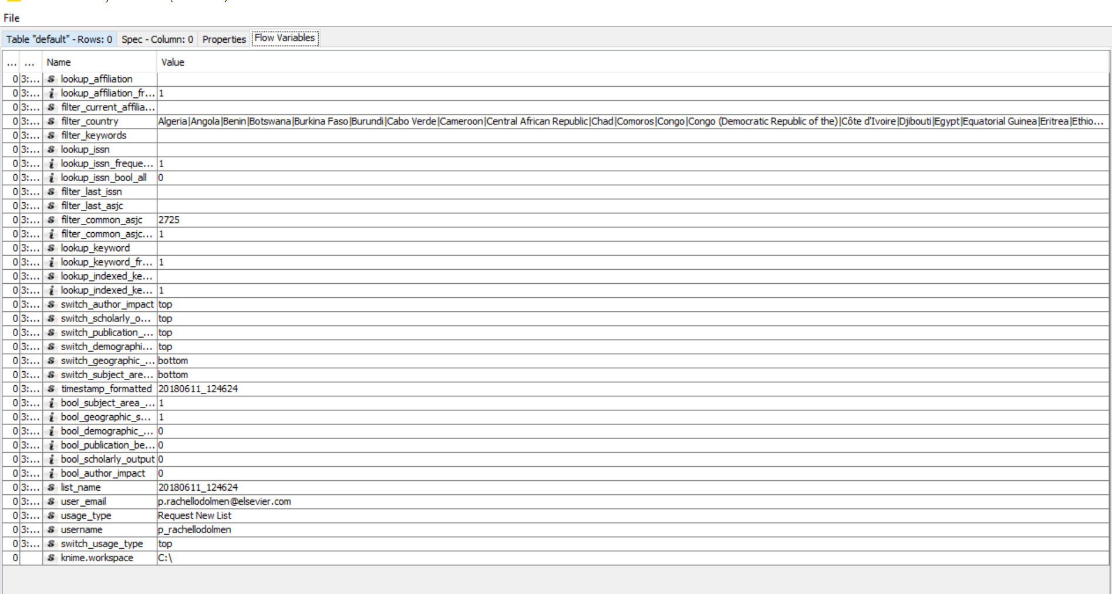

The complete row is:

Filter_country (STRIG) Algeria|Angola|Benin|Botswana|Burkina Faso|Burundi|Cabo Verde|Cameroon|Central African Republic|Chad|Comoros|Congo|Congo (Democratic Republic of the)|Côte d'Ivoire|Djibouti|Egypt|Equatorial Guinea|Eritrea|Ethiopia|Gabon|Gambia|Ghana|Guinea|Guinea-Bissau|Kenya|Lesotho|Liberia|Libya|Madagascar|Malawi|Mali|Mauritania|Mauritius|Mayotte|Morocco|Mozambique|Namibia|Niger|Nigeria|Réunion|Rwanda|Saint Helena, Ascension and Tristan da Cunha|Sao Tome and Principe|Senegal|Seychelles|Sierra Leone|Somalia|South Africa|South Sudan|Sudan|Swaziland|Tanzania, United Republic of|Togo|Tunisia|Uganda|Western Sahara|Zambia|Zimbab

Should be Zimbabwe

First window with different categories. In total there are 6 categories
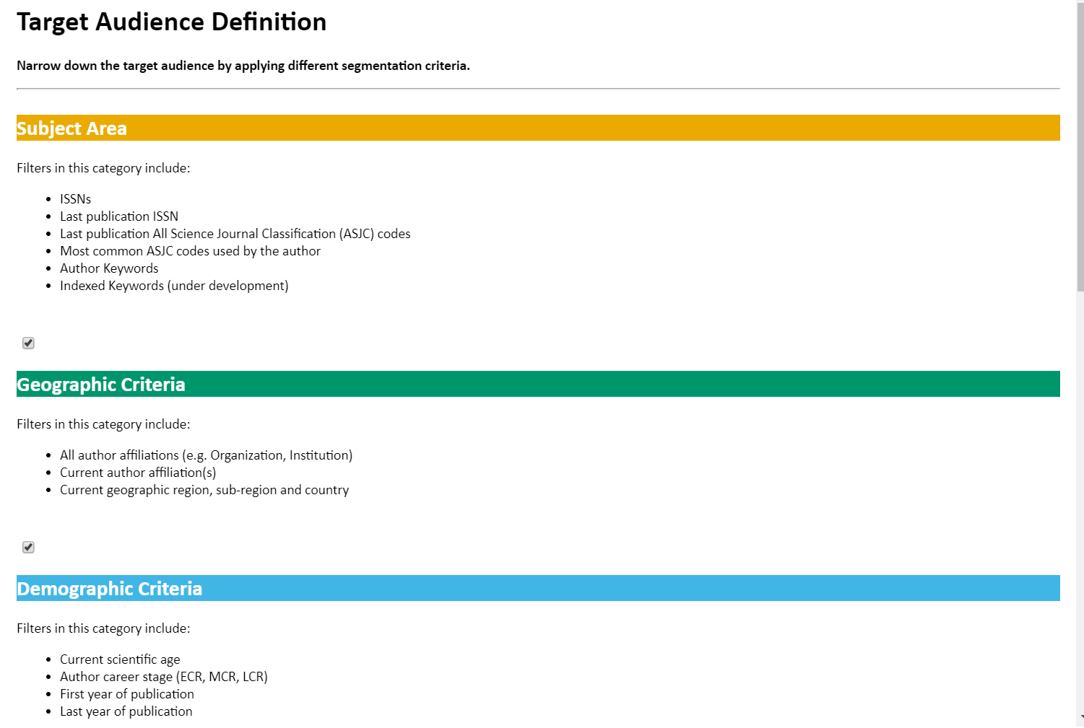

Part of the workflow

