Schedule for project:
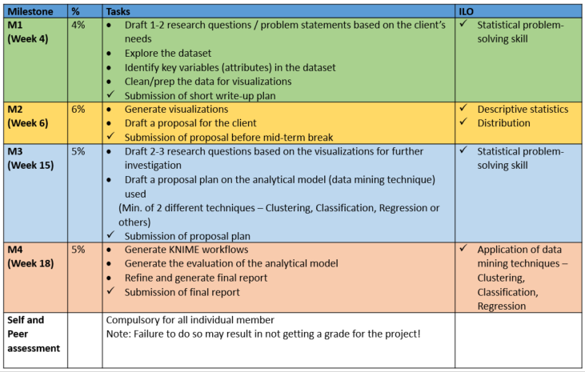
1.
2.
3.
Name/ ID:

Module class:
Tutor:

Introduction
[Give a description of the dataset that you are working on.]

Dataset
[Give description of all the attributes of the dataset that you are working on and provide any information of the source, if any.]

Identify the problem
[Describe/ define the problem that you want to solve for the dataset.]

Data Preparation/ Data Exploration
M2
- Identify key variables (attributes/features) in the dataset.
- Clean/Prep the data for visualization/exploration.
- Draft the plan for visualization techniques used for exploration. In the steps of the plan, explain the rationale of the intended visualization techniques to be used.
- Generate interesting insights/interpretation based on the visualizations. (Place all your visual graphs/representations here.)
M1

Analytical Modelling
M4
M4
M3
M3
More models: …
Model 2
- Craft research questions/ problem statements using key interesting insights generated from the initial visualization/ exploration above.
- Choose a suitable data mining technique (clustering, classification, regression) and draft the plan explaining why the technique chosen is suitable to address the research questions/ problem statements.
- Present the workflow.
- Interpret the results and present the findings/ insights gathered.

Model 1
- Craft research questions/ problem statements using key interesting insights generated from the initial visualization/ exploration above.
- Choose a suitable data mining technique (clustering, classification, regression) and draft the plan explaining why the technique chosen is suitable to address the research questions/ problem statements.
- Present the workflow.
- Interpret the results and present the findings/ insights gathered.

Evaluation
M4
M4
More models: …
Model 2:
Evaluate the model selected above and report the findings.
Model 1:
Evaluate the model selected above and report the findings.

