An old workflow

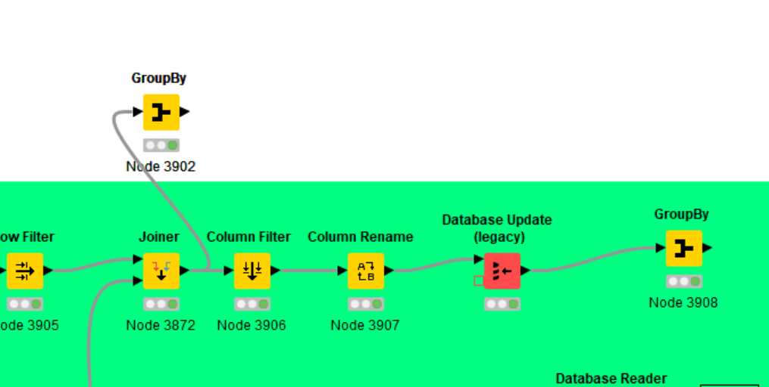
Inside the update node, we have this :
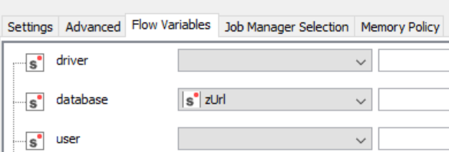
- zUrl is a workflow variable

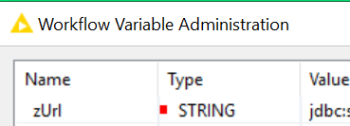

(Please check next page)

Now, if i just copy & paste that node
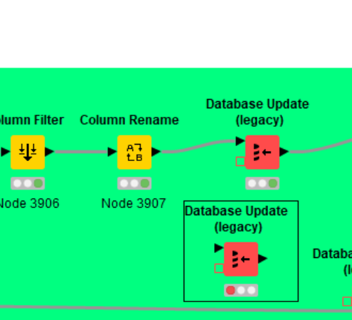

Fron inside that new node, it’s now impossible to retrieve Workflow variables
